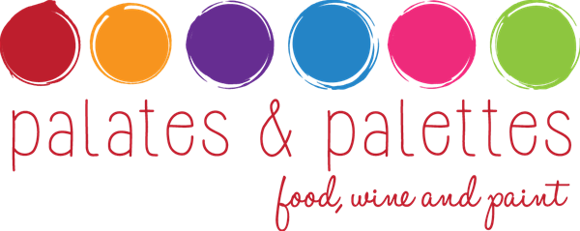

April 18: Matisse, Color & Fauvism and the wines of Southern France.

Art Inspiration – Henri Matisse (1869 – 1954)

South of France – Outlines – Bright Colors

Wine & Food Pairings

Moet & Chandon, Grand Vintage Rosé, 2004

California bass tartare

roasted red bull onions, pickled Valencia orange, The Farm beet chips

Château De Lugagnac, Grand Vin Rosé, Bordeaux, 2013

Poached fired sable

wild arugula, farm chili, shaved black radish, Marcona almond

Château Croizet-Bages, Grand Cru Classé, Pauillac, 2011

Duroc pork belly

frilly mustard, fava bean, birch syrup

Vidal-Fleury, Crozes-Hermitage, 2010

Brandt beef striploin

glazed market carrot, swiss chard, oak aged vinegar

cherry wood-smoked, dark chocolate mousse

Amarena cherry, génoise croutons, Indian mint

Artist/host: E. Dominic Black
Wine Selections: Fairplex Certified Sommelier Mary Ellen Cole, Sheraton Fairplex
Food Pairings: Vinny Cavalli, McKinley’s Grille
Millard Sheets Art Center Manager: Thomas Canavan

