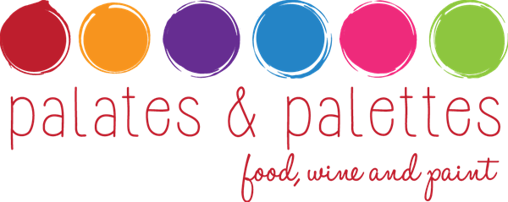

March 21: Monet, Impressionism and the wines of Northern France

Art Inspiration – Claude Monet (1840 – 1926)

Impressionist – Paris - Giverny – color as content

Wine & Food Pairings

Jolie Folle Sauvignon Blanc Loire Valley 2013

San Joaquin Valley asparagus, pickled shallot, Fourme d'Ambert, Maldon salt

Domaine de la Saraziniere Macon Bussieres 2013

Seared octopus, Marcona almond, warm bistro vinaigrette

Domaine Grosbois "La Cuisine de Ma Mere" Chinon 2013

Stuffed poulet bleu, braised mustard greens

Chateau Aney Haut-Medoc 2011

Seared lamb loin, braised French lentil, Valencia orange

Domaine Ferrer Ribiere Muscat de Rivesaltes 2012

Apple tart with Calvados caramel

Artist/host: E. Dominic Black
Wine Selections: Randy Clement, Silverlake Wine
Food Pairings: Vinny Cavalli, McKinley’s Grille
Millard Sheets Art Center Manager: Thomas Canavan

